|  |
| --- |
|  |
| EMI Sensor Report |
|  |

|  |
| --- |
| Jonah Smith |

**Introduction**

This report is meant to document the work done by Jonah Smith on designing a Multi-Frequency EMI Soil Conductivity sensor and integrating the GEM-2 sensor for Dr. Stacey Kulesza apart of the Pancreas Sensor bot project. I will begin by describing works that helped me understand how these sensors worked and designing one. Then I will describe where I am at in the design of the EMI sensor. Finally, I will discuss the integration of the GEM-2 Sensor.

These sensors are intended to be used for determining if certain chemicals are present in soil. To do this the sensor must sweep a frequency range of approximately 20 to 96 KHz. This range was determined through the needed depth and the limitations of this type of sensor i.e. low induction numbers that will be discussed later. The upper limit cannot be changed due to these limitations, but the lower limit can easily be decreased to 200 Hz simply in the programming of the sensor. In my research of available literature, I did not find any instances of this type of sensor being used in this way, other than for salinity and moister content. In fact, Geophex, the makers of the GEM-2, is the only company that currently produces a multi-frequency version of this sensor and it is not designed to sweep more that 10 frequencies in one survey. This is why it has been determined that it is necessary to design a custom-built sensor.

Table of Content

**Theory of Sensor** 3

**Useful Works** 4

**Sensor Design** 4

Microcontroller 4

Transmitter 5

Reciever 5

Coil Parameters 5

Ski Layout 5

**Gem-2 Sensor Integration** 6

**Contact Info and File Locations** 6

References 7

### **Theory of Sensor**

EMI soil conductivity meters have been available since 1985 when Geonics introduced their EM31 and EM34-3 (McNeil, 1980). The basic operation of an EMI sensor is shown in Figure 1. To find the soils conductivity the EMI sensor emits a time varying EM wave. Then according to Faraday’s law, the EM wave will induce a current into the soil. This current will also emit its own EM wave that can be measured by the Rx coil. This secondary EM wave will be indicative of the soils properties when compared to the original EM wave. Geonics’s sensors and all EMI soil conductivity meters that have followed are designed around a set of assumptions referred to as “Low Induction Numbers” (McNeil, 1980). McNeil (1980) also introduced the concept of apparent conductivity. This differs from traditional conductivity in that it considers the entire half-space that is measured to be of uniform material. These assumptions allow for the conductivity of soil to be measured with EM waves. A simple equation was developed and can be easily used to find the apparent conductivity by measuring the magnetic field that is created through induction by the soil. With the addition of multiple Rx coils, at different spacings (McNeil, 1980), or multiple frequencies (Huang, 2005) a layered earth model can be produced to determine the apparent conductivity of multiple layers of soil. This is due to the spacing of the Rx and Tx coils and the skin depth of the frequency used to measure the conductivity all effect the depth of investigation of the soil (Huang, 2005). With these measurements a model of some of the soil’s properties can be made and displayed in a plot such as the one in Figure 2.

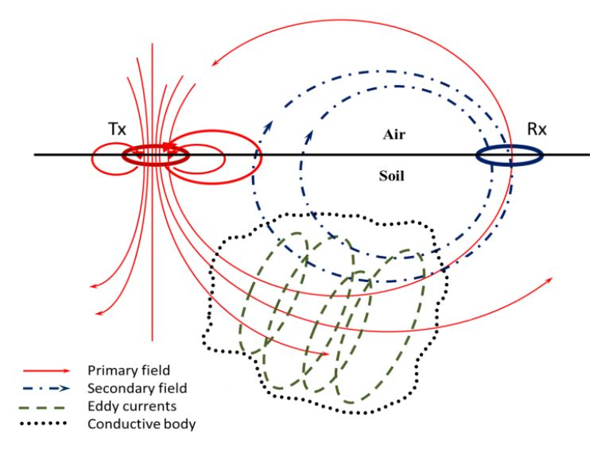

Figure 1: Simplified representation of the basic principle of electromagnetic (Manstein, Manstein, Balkov, Panin, & Scozzari, 2015)

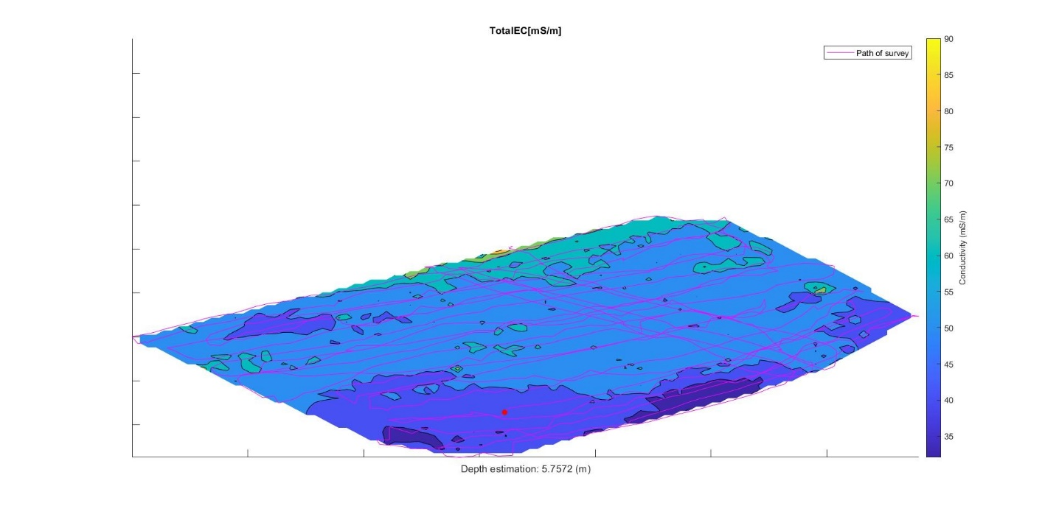

Figure 2: Contour Plot of Soil Conductivity from the GEM-2 Sensor

### **Useful Works**

Many of the works that I have found useful have been mentioned above. Electromagnetic Terrain Conductivity Measurement at Low Induction Numbers by JD McNeil has been very useful in understanding much of the theory and needed equations for determining soil conductivity. “A Portable Frequency Domain Electromagnetic System For Shallow Metal Targets Detection” (Qu, Li, Fang, & Yin, 2017) has been the most useful for actually designing the sensor. The sensor described in this paper has been the basis for most of my designs. I would highly recommend these two papers for anyone who wants to fully understand the design of these sensors.

### **Sensor Design**

As mentioned above the design of this sensor was mainly based on the paper “A Portable Frequency Domain Electromagnetic System For Shallow Metal Targets Detection” (Qu, Li, Fang, & Yin, 2017). This paper describes the design of the CEM 2 sensor. The only major differences are the microcontroller used, the ADCs used and the Tx driving circuity.

### Microcontroller

In the second revision of the sensor board a STM32F7 microcontroller is used as the main controller. This microcontroller can be programmed with the STLINK-V3Mini and the header pins on the board. STM32CubeIDE is the needed IDE for progamming this microcontroller. It can be found through the STMicroelectronics website. This microcontroller needs to communitcate with the ADCs through the SPI connections. There are also several pins for controlling the OSR and filters of the ADCs. These will all need to be set at the start up of the microcontroller. At the time of the design I was unsure of which settings would need to be used so I did this so that it could be easlily changed afterwards. The transmitter needs a SPWM wave created on pins PE11 and PE9. This is fed into the motorcontroller and will create the current waveform on the transmittting coil. This SPWM wave needs to be at the needed frequency or frequencies for the survey. A digital pot is also included for controlling the variable voltage source for the transmitting coil. This is needed so that the current (and magnetic moment) can be controlled so that proper canceling of the primary field at the Rx coil is achieved. The digital pot is controlled through the SPI port labeled Tx_SPI. A micro SD card slot has also been included for storing survey information. The STM32CubeIDE has an included library for communicating with the card. A RS-232 port has also been included in order to communicate with the Pancreas robot. This can be done through the DO serial port on the microcontroller.

### Transmitter

The transmitting circuitry consists of the DRV8412 motor controller and a variable power supply. The motor controller should provide fast enough operations to support a SPWM frequency of up to 100 KHz. The motor controller is a CMOS H-bridge with the needed control circuitry included. The only real communication needed between the microcontroller and this motor controller is the PWM signal created by the microcontroller, but fault pins and a reset pin are also included. The variable power supply is a varente of the circuit described by (Szolusha, 2014). The main differences are the voltage controlling pot has been switch to a digital pot and the current limiting function has been switched to a fix value. The voltage source needed to drive the circuit to 0V has also been removed since this is not needed.

### Reciever

The receiving circuit first starts with a differential connection of the Rx coil and Bx coil. Then the signal across this connection and across the Bx coil are amplified by a LNA and then fed into two Sallen-Key bandpass filters. The signals are then turned into a differential connection, buffered, and then sampled by two ADCs. These samples are sent to the Microcontroller through a SPI connection.

### Coil Parameters

Each of the coils for this sensor are made from 3-D printed ABS plastic and where designed by Calvin Dahms. Each coil is 17x12x2.9 cm. The Tx coil has 4 coils connected in parallel that are 100 turns each. The Rx coil has 400 turns and the Bx coil has 100 turns. The wire is 25 AWG gage magnetic wire. These dimensions are very similar to the CEM 2 (Qu, Li, Fang, & Yin, 2017).

### Ski Layout

The “Ski” is the surface the control board and coils are connected to. The target length for the ski is 1 m, but to begin with the same dimensions of the CEM 2 will be used with a Rx and Tx spacing of 1.67m and Bx and Tx spacing of 1.06m (Qu, Li, Fang, & Yin, 2017). This is to ensure that the sensor is working properly first, then the size can be changed afterwards. For the primary field to be cancelled at the receiving coil the following equation should be followed. $\frac{M_{1}}{r_{1}^{3}}=\frac{M_{2}}{r_{2}^{3}}$ (Manstein, Manstein, Balkov, Panin, & Scozzari, 2015) where M1 and M2 are the magnetic moments of the Bx (M1) and the Rx (M2) coils, and r1 and r2 are the respective distances from the Tx coil. This equation should allow the adjustment of the coil spacing to 1m and should also be followed when adjusting the current sent to the Tx coil for each frequency. The control board should be mounted in between the Bx and Tx coil. The ski can be made from any low conductivity material such as wood or fiberglass.

### **Gem-2 Sensor Integration**

Two Gem-2 sensors where purchased from Geophex at the beginning of this project. These sensors are multi-frequency EMI conductivity sensors and are very similar to the sensor being designed. These sensors were originally designed to be carried by a person or pulled in a sled by a vehicle. To use these sensors remotely we have been given a library by Geophex to communicate with the sensor through the RS-232 port on the sensor. To do this I believe that a single board computer will need to be used to interface with the sensor and the myRIO board on the pancreas robot. This library should allow the computer to control the starting and stop of a survey and record data. I believe it will also allow the computer to set the frequency of the survey, but I was not able to confirm this, and more investigation of the library needs to be done. If this can be done hopefully more than 10 frequencies can be used in a single survey and will more closely matching the hopes of Dr. Welsh. This library can be downloaded from <https://www.dropbox.com/s/0jwxj14118n55y3/GEM2_LIB_v1.4.zip?dl=0> and will be included with the rest of the design files.

### **Contact Info and File Locations**

All of the design files, useful papers, and data from surveys done by the Gem-2 can be found on the BAE server or from the Github link <https://github.com/95jasmith/EMI-sensor>. Robert Lawson has been my main point of contact with Geophex and is the sales rep. His email is [blawson@geophex.com](mailto:blawson@geophex.com). He has been very helpful and quick to respond to emails.

# References

Geophex. (n.d.). *Frequently Asked Questions*. Retrieved from Geophex: http://www.geophex.com/faq.htm#depth

Huang, H. (2005). Depth of investigation for small broadband electromagnetic sensors. *GEOPHYSICS, 70*(6), G135-G142. doi:https://doi.org/10.1190/1.2122412

Kustarev, V. (2016). *Multilayer air core inductor on a rectangular former*. Retrieved from coil32: https://coil32.net/online-calculators/rectangular-multilayer-inductor-calculator.html

Manstein, Y. A., Manstein, A. K., Balkov, E., Panin, G., & Scozzari, A. (2015). Non-invasive measurements for shallow depth soil exploration: Development and application of an electromagnetic induction instrument. *Instrumentation and Measurement Technology Conference,(I2MTC),IEEE.* Pisa, Italy: IEEE. doi:10.1109/I2MTC.2015.7151479

McNeil, J. (1980, October). *Electromagnetic Terrain Conductivity Measurement at Low Induction Numbers.* Retrieved from Geonics: http://www.geonics.com/pdfs/technicalnotes/tn6.pdf

Qu, X., Li, Y., Fang, G., & Yin, H. (2017). A PORTABLE FREQUENCY DOMAIN ELECTROMAGNETIC SYSTEM FOR SHALLOW METAL TARGETS DETECTION. *Progress In Electromagnetics Research M, 53*, 167-175. doi:10.2528/PIERM16111603

Renge, M., Suryawanshi, H., & Chaudhari, M. (2010). Digitally Implemented Novel Technique to Approach Natural Sampling SPWM. *EPE Journal, 20*(1), 13-20. doi:https://doi.org/10.1080/09398368.2010.11463744

Thiesson, J., Kessouri, P., Schamper, C., & Tabbagh, A. (2015). Calibration of frequency‐domain electromagnetic devices used in near‐surface surveying. *Near Surface Geophysics, 12*(4), 481-491. doi:https://doi.org/10.3997/1873-0604.2014012